**SE 251 Summer 2017**

**Final**

**Practical Exam**

**Instructions:** download the zip file from Canvas. This file will contain start files for each of the below web pages as well as an index.html page. Modify index.html page to display your name. When you’re done editing all of the documents, you will need to upload all pages, including index.html, to ict.neit.edu. You will then submit the URL to index.html to Canvas. Do not leave the classroom until the instructor has verified the link. Failure to have this checked may result in a 0 for the exam. You must also upload a zip of all of your code to Canvas.

Your job is to write the JavaScript for the assignments. You will not need to edit the HTML for any of the pages except for index.html. Be sure to use loops where you can and be clever with selectors.

**Baseball Teams** (5 points)

Given the standings array in q2Baseball.html, use JavaScript to dynamically create a table that displays all of the information in the array. Each team with a winning record (> .500) should have a winning class associated with it: class='winning'. Each team with a losing record should have class='losing'. After generating the table, use document.getElementsByClassName or document.querySelectorAll() to change the font color for the winning teams (the whole <tr>) to blue. Then use a jQuery selector to .7change the color for the losing teams to red.

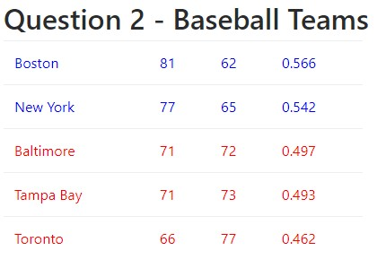

* 3 points for generating the table.
* 1 points for changing the winning teams to blue
* 1 points for changing the losing teams to red.

**Question 5: Disney Characters** (5 points)

Program the three buttons in q5disney.html to display each of the three Disney characters along with their name and quote. You are to pull this through an Ajax call from: [http://ict.neit.edu/evanrense/disney/disney.php.](http://ict.neit.edu/evanrense/disney/disney.php)

Note that you can pass in different character numbers to this page: <http://ict.neit.edu/evanrense/disney/disney.php?character=1>etc.

See q5disney.mp4 for a 3 second video of the desired behavior.

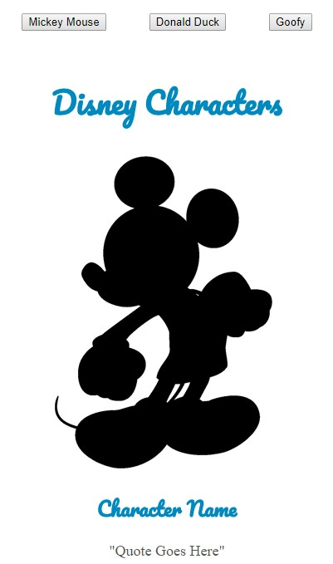

* .5 point for retrieving and console.log() data.
* .25 points for each button that is clickable   
  *(event if they simply console.log or alert)*
* .25 points per button for changing the quote when the corresponding button is clicked.
* .25 points per button for changing the character name when the corresponding button is clicked.
* .25 points per button changing the image when the corresponding button is clicked.
* .25 points for each button that works as demonstrated in the video
* .75 points for using the retrieved data to complete this program